CANDIDATE PACK
– Resident Assistants -
START DATE SEPTEMBER 2021
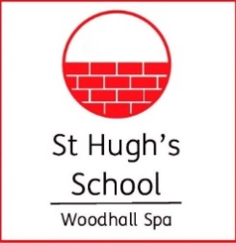

Resident Assistants (2021-22)

Two exciting opportunities have arisen to join the team at this thriving Prep School.

If you are considering a career in teaching and are skilled in sports, as well as other areas of the school, we would love to receive your application.

This is a busy role, requiring natural enthusiasm and an ability to work with adults and children. In return you will receive term-time accommodation, with meals included, and you’ll be an integral part of a passionate team at an energetic school. with a hands on and collegiate approach to working in a school.

The deadline for applications is Friday 28 May 2021, however we reserve the right to appoint earlier for the right candidate.

Do visit our website to find out more about the school and if you require any further information, please contact the school at office@st-hughs.lincs.sch.uk

St Hugh’s School is committed to safeguarding and promoting the welfare of children. Consequently a Disclosure and Barring Service Certificate is required for every post.

www.st-hughs.lincs.sch.uk

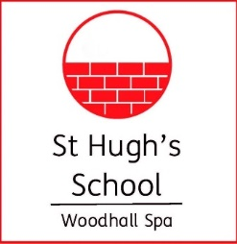
Welcome to St. Hugh’s and thank you for expressing an interest in joining us as a member of staff.
The ethos of St. Hugh’s is driven very much by a sense of community and an environment where everybody can find their way to make an impact.
We are a thriving school with children from the age of 2 in the Nursery right up to 13 years of age in Year 8 and our small class sizes and family atmosphere mean that we can focus on the key aspects of education. We never forget the importance of childhood and the range of activities on offer here, most of which are run by staff from across the school, is the envy of many schools in the area.
Our minibuses bring children to us from all areas of Lincolnshire and we have routes which run from Lincoln, Skegness, Louth, Sleaford, Boston and Market Rasen. A significant number of children are boarders here and, to them, school is very much a home from home. They live in school from Monday to Friday, looked after by our resident staff.
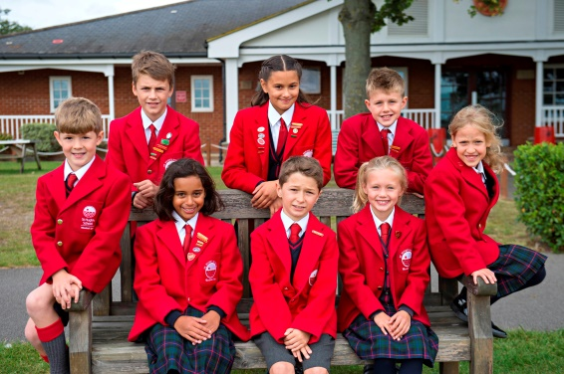
St. Hugh’s is a family school, firmly linked to the local community and we are proud of our connection to the village. We host events for local residents, we source our food from local producers and we strive to play our part in the town we are proud to call home. We are especially proud of our connections to the armed forces; many families from the British and American forces have chosen us and we are pleased to be linked to a number of local bases.
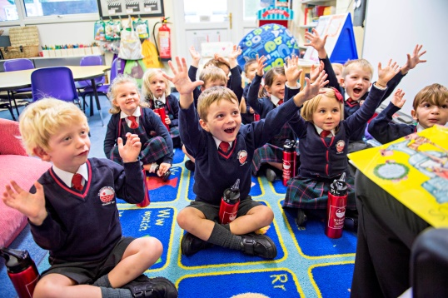
With 160 children and over 50 members of staff, St. Hugh’s is a school where everyone knows everybody. Each member of staff, be they admin, support, catering, or teaching, enjoys working here and particularly the energy and enthusiasm that greets you as you arrive.
I’d very much like to welcome you to the school to get a sense for this yourself and, if you think St. Hugh’s is also right for you, I look forward to receiving your application to join us. If you wish to know more, please don’t hesitate to contact the school.
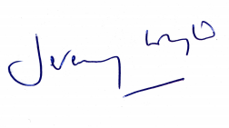
Yours sincerely,

Jeremy Wyld, Headmaster

Graduate / GAP Assistants from September 2021

Role Description:
- To assist as part of a duty rota with the supervision of boarders’ clubs, activities and the bedtime routine.
- To assist with the wake-up and the breakfast routine.
- To lead activities and clubs (suited to your skills) for pupils
- To work closely with the Head of Boarding and other boarding staff to create a warm, welcoming and family atmosphere within the House.
- To help staff deliver the School’s Wrap-around Care provision.
- To support the delivery of PE lessons by a member of the school’s teaching staff.
- To assist teaching staff with administrative tasks, classroom activities and project work where possible.
- To participate in the duty rota for supervising pupils at break, lunch and other times, as required.
- To accompany pupils and staff on educational visits e.g. museums and camping expeditions.
- To work closely with the Director of Sport and assist and lead in the daily Games Coaching sessions, including taking teams and refereeing.
- To provide Lifeguarding cover at the swimming pool during PE, Games and Activities (RLSS NPLQ training will be arranged for you by the school).
- Additional hours (e.g. for staff swimming) may also be available, remunerated separately.

Terms and Conditions:
• We are seeking to appoint a candidate on a One Year Fixed Term Contract for the period 1 September 2021 to 2 July 2022.
• The role attracts an annual salary from £9,000 to £12,000* per annum depending on the profile of the successful candidates and paid in 12 equal instalments.
• The role is for 40 hours per week and for 35 weeks of the year. The working pattern will be variable but will ordinarily fall between 7:00 am and 9:00 pm, Monday to Friday inclusive, term time only. There will also be a need for regular evening hours to support school events and to assist in the Boarding House (as outlined above). There will be free time during the day in accordance with the timetable. Wake-up, breakfast and bedtimes duties will be rotated between the boarding staff team. St Hugh’s School only offers boarding on 4 nights of the week, Monday to Thursday inclusive, but the option of Sunday is offered to parents and this is staffed on a rota with the other Residential Assistant.
• 38 days paid holiday (inclusive of 8 bank holidays), applied pro rata for part time staff, are included in the 40 weeks and are to be taken during school holidays.
• For the proper performance of your boarding duties, accommodation is provided for the period of employment. Free school meals (breakfast, lunch and dinner) and refreshments are provided during term time and INSET days.

