We are very much looking forward to hosting you at the upcoming U11 IAPS Netball Festival
Please find details below:
FRIDAY 24 January 2025 @ Stamford Junior School Kettering Rd, Stamford PE9 2LR 0945 start (approx. 1330 finish)
- Please send the attached maps to visiting parents to help reduce congestion during the afternoon.
- Please make sure spectators know there is NO PARKING onsite.
Please direct parents to park in town. Public car parks include:
  - Cattle Market – PE9 2WB
  - Bath Row – PE9 2WE
  - Scotgate – PE9 2YE
  - North Street – PE9 1EG
  - St. Leonard’s Street – PE9 2HX
  - Wharf Road – PE9 2EB
- Minibuses should park at the Stamford Junior School Nursery Car Park (PE9 2WB). Please let us know if you require a parking spot reserving for your minibus.
Coaches should drop off and collect from the layby outside Stamford 6th Form (PE9 2LL) and walk down Kettering Road to the courts as there is no coach drop off at courts.
- Court allocation: We will have 5 playable courts and a warmup court (which will not be used for match play due to tree roots incursion) – the order of play is below.
- Game details: U11 netball competitions
Rules summary - All IAPS competitions are run in line with national governing body (NGB) rules and regulations (England Netball).
Bee Netball is the format of the game for all children U11.
The U11 competition will play Stage 3 (Stinger) of Bee Netball. England Netball | Stinger – Rule Adaptations
This incorporates a minimum squad size of 7 players (can take a squad of up to 9) with 5 on the court at any one time.
- Umpiring: We will have a number of umpires onsite who will assist in rotation, but we cannot cover all the courts so PLEASE be prepared to chip in!
- Medical: Assistance will be available, but please bring your medibags.
- Facilities: Toilets are available in the Wothorpe Sports Centre, over the Kettering road (there is a pelican crossing to assist crossing) and there will be payable refreshments available there for spectators and visitors. We will provide tea, coffee, snacks for visiting staff.
- The festival will be run in the same positive, relaxed spirit as always!

ORDER OF PLAY

POOL MATCHES
- This qualifier consists of 2 pools of 6 teams.
- Matches will be 6 minutes each way.
- Straight swap over at half time and 3 minutes between games.
- The 1st and 2nd placed team in each pool will progress to the cup competition.
- The 3rd and 4th placed team in each pool will progress to the plate competition.
- The 5th and 6th teams in each pool will progress to the bowl competition.

 | POOL 1 |  | POOL 2
A1 | Stamford Junior School | B1 | Fairfield Preparatory School
A2 | Manor Lodge School | B2 | Stephen Perse Foundation – Rosedale House
A3 | Witham Hall School | B3 | St Hugh’s School
A4 | Langley Preparatory School at Taverham Hall | B4 | Gresham’s Prep School
A5 | King Henry VIII Junior School | B5 | Orwell Park School
A6 | Barnardiston Hall Prep | B6 | Wellingborough Prep School

KNOCKOUT MATCHES
Round | Time | Court Number
Round | Time | 1 | 2 | 3 | 4
1 | 0945 | A1 v A2 | A4 v A5 | A3 v A6
2 | 1000 | B1 v B2 | B4 v B5 | B3 v B6
3 | 1015 | A1 v A3 | A2 v A5 | A4 v A6
4 | 1030 | B1 v B3 | B2 v B5 | B4 v B6
5 | 1045 | A2 v A6 | A1 v A5 | A3 v A4
6 | 1100 | B2 v B6 | B1 v B5 | B3 v B4
7 | 1115 | A2 v A4 | A3 v A5 | A1 v A6
8 | 1130 | B2 v B4 | B3 v B5 | B1 v B6
9 | 1145 | A2 v A3 | A1 v A4 | A5 v A6
10 | 1200 | B2 v B3 | B1 v B4 | B5 v B6
11 | 1215 | REGROUP
12 | 1230 | Cup SF1 | Cup SF2 | Plate SF1 | Plate  SF2
13 | 1245 | Bowl SF1 | Bowl SF2 | Cup 3rd/4th play off | Plate  3rd/4th play off
14 | 1300 | Bowl 3rd/4th play off | Cup  FINAL | Plate  FINAL | Bowl FINAL
15 | 1315 | PRESENTATIONS

CUP COMPETITION
SF 1 | SF 2
1st place pool 1 v 2nd place pool 2 | 1st place pool 2 v 2nd place pool 1
FINAL | 3RD & 4TH PLAY-OFF
winner of SF 1 v winner of SF 2 | 2nd place of SF1 v 2nd place of SF 2

PLATE COMPETITION
SF 1 | SF 2
3rd place pool 1 v 4th place pool 2 | 3rd place pool 2 v 4th place pool 1
FINAL | 3RD & 4TH PLAY-OFF
winner of SF 1 v winner of SF 2 | 2nd place of SF1 v 2nd place of SF 2

BOWL COMPETITION
SF 1 | SF 2
5th place pool 1 v 6th place pool 2 | 5th place pool 2 v 6th place pool 1
FINAL | 3RD & 4TH PLAY-OFF
winner of SF 1 v winner of SF 2 | 2nd place of SF1 v 2nd place of SF 2

Maps
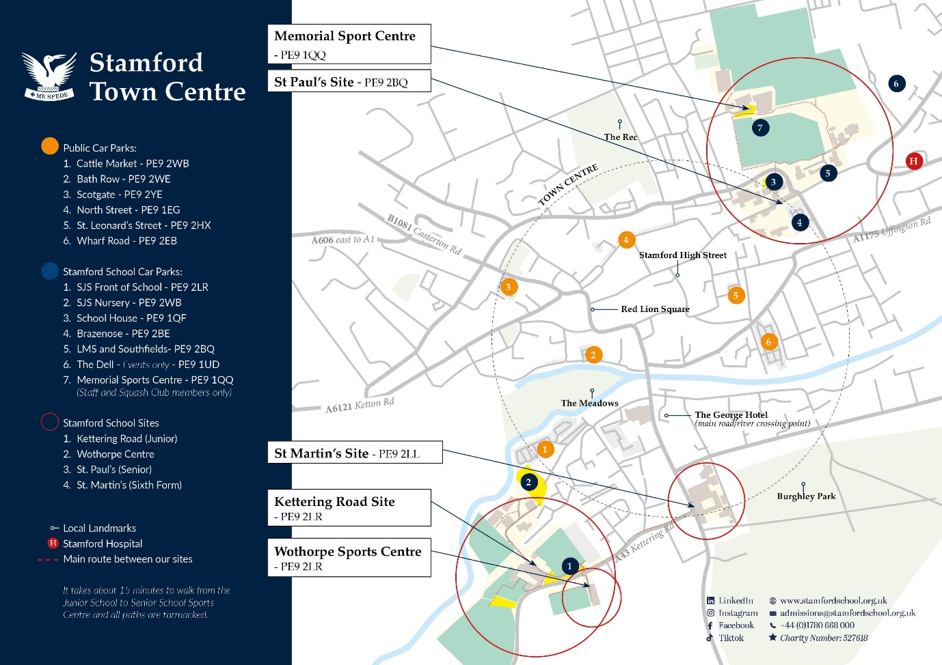
Blue spot No.2 should be used for school Minibus parking. There is a public car park (orange spot 2) next to it for visitors/spectators.

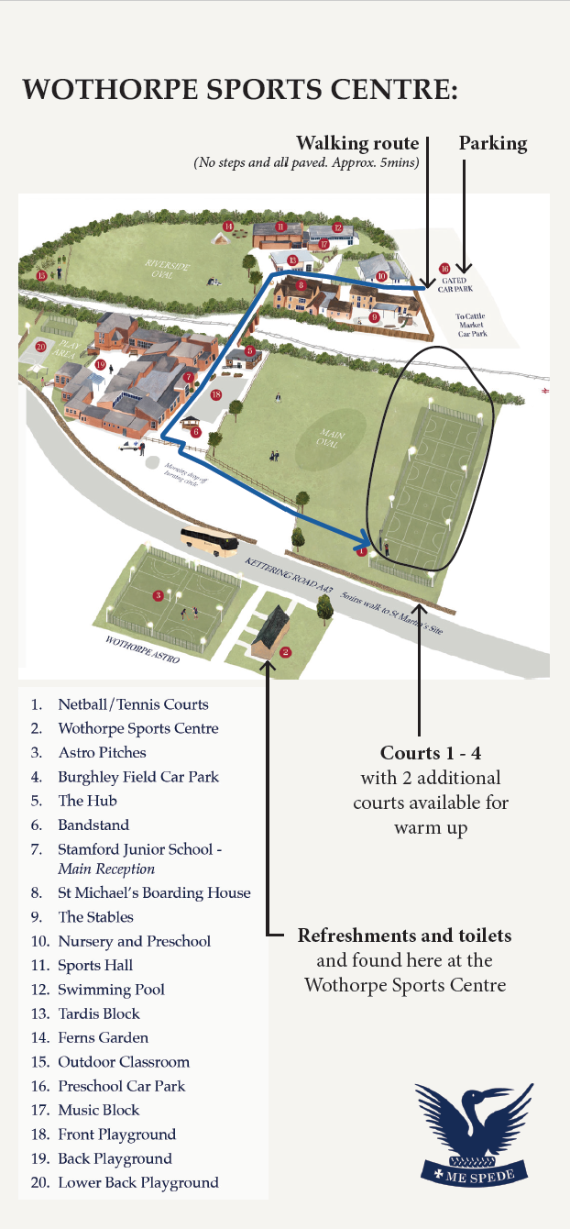
Once mini buses are parked, teams may walk through the school but please remember that the junior school will be in operation.
We will have a member of staff on hand to marshal attendance.

